TOGAF® Architecture Requirements Specification (Phase B)
Version 0.1, 2026-10-30
CSA Mentoring Unit Enterprise Architecture (A3)
Office of Student Mentoring (Mentoring Unit), Center for Student Affairs, University of Asia and the Pacific
Document Version History
Version  Number | Version  Date | Revised By | Description | Filename
0.1 | 2026-10-30 | Aldrin (with Laufey) | Phase B draft | Architecture Requirements Specification.docx

Contents
1. Purpose of this Document 4
1.1 Output and Input 4
2. Architecture Requirements 4
2.1 Success Measures 7
2.2 Business Service Contracts 8
2.3 Application Service Contracts 9
2.4 Implementation Guidelines 10
2.5 Implementation Specifications 10
2.6 Implementation Standards 10
2.7 Interoperability Requirements 10
2.8 IT Service Management Requirements 11
2.9 Constraints 11
2.10 Assumptions 11
Tracking Information
Project Name | CSA Mentoring Unit Enterprise Architecture (A3)
Prepared By | Aldrin | Document Version No. | 0.1
Title | Architecture Requirements Specification | Document Version Date | 2026-10-30
Reviewed By | Pending: Emmanuel Velasco, Deejay Clark Datu | Review Date
Distribution List
From | Date | Phone/Email
Aldrin | 2026-10-30

To | Action* | Due Date | Phone//Email
OSM Operations Coordinators | Review
CSA Executive Director (Sponsor) | Approve
Architecture team (Velasco, Aldrin, Datu) | Inform
* Action Types: Approve, Review, Inform, File, Action Required, Attend Meeting, Other (please specify)

Purpose of this Document
The Architecture Requirements Specification provides a set of quantitative statements that outline what an implementation project must do in order to comply with the architecture. An Architecture Requirements Specification will typically form a major component of an implementation contract or contract for more detailed Architecture Definition.
As mentioned above, the Architecture Requirements Specification is a companion to the Architecture Definition Document, with a complementary objective:
The Architecture Definition Document provides a qualitative view of the solution and aims to communicate the intent of the architect.
The Architecture Requirements Specification provides a quantitative view of the solution, stating measurable criteria that must be met during the implementation of the architecture.

Output and Input
The TOGAF® Content Framework (see Architecture Deliverables) identifies deliverables that are produced as outputs from executing the Architecture Development Method (ADM) cycle and potentially consumed as inputs at other points in the ADM.
This deliverable is produced, updated, and consumed by the ADM Phases:
Deliverable | Output from… | Input to…
Architecture Requirements Specification | B, C, D, E, F,  Requirements Management | C, D,  Requirements Management

Architecture Requirements
This specification states the measurable requirements that come out of the Phase B Business Architecture for the Office of Student Mentoring (OSM). It covers the business-level requirements only. The Application, Implementation, Interoperability and IT Service Management sections are marked for completion in Phases C and D.
Motivation. Goal: foster holistic (integral) education in line with UA&P's vision. Objective: see student growth closely. Drivers: (1) the new University President's mandate making mentoring mandatory, with at least three mentoring sessions per semester (non-negotiable; missing it for two consecutive semesters affects enrollment); (2) mentoring as a UA&P hallmark that CHED does not require; (3) the need for evidence that the program works, aiming at full participation.
Business-level target. All mentoring workflows (pairing, mentor change, mentee contact, session logging and monitoring) run as one centralized, end-to-end workflow with one shared source of truth for mentee-mentor pairings, replacing today's email chains and per-coordinator spreadsheets. School Mentoring Coordinators keep the pairing decision.
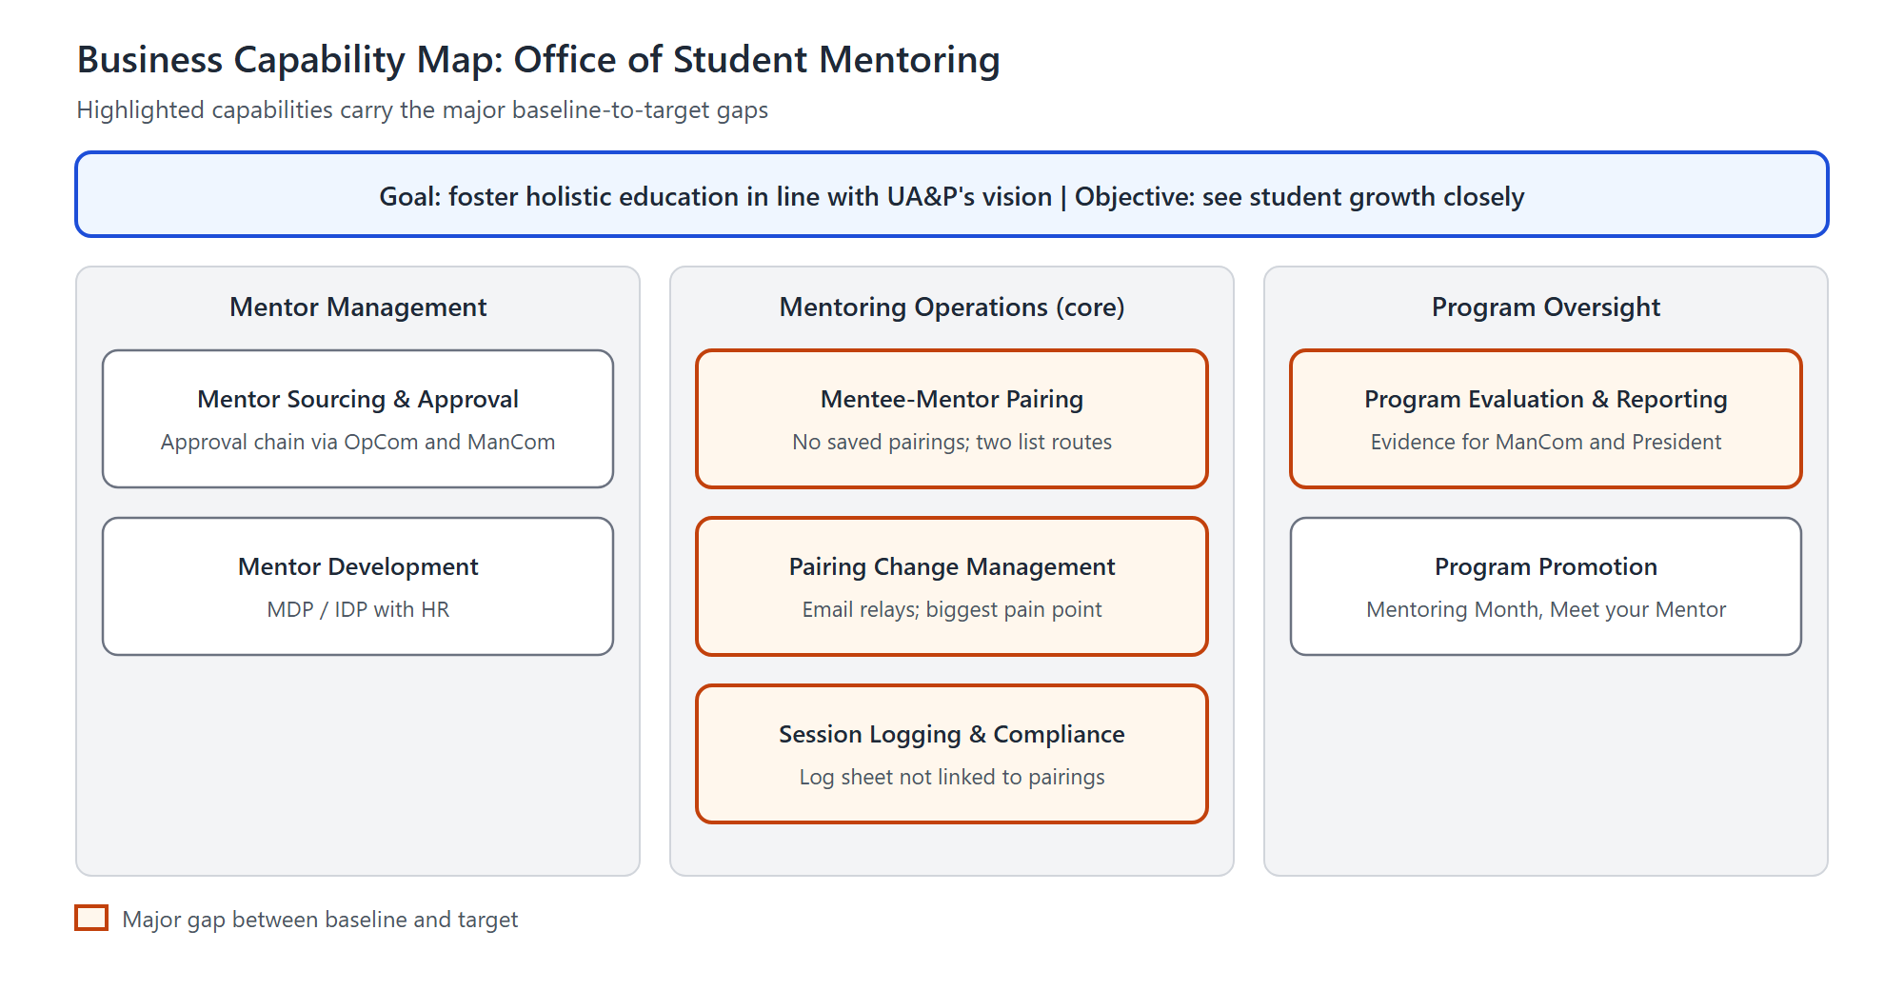
Figure 1. Business Capability Map
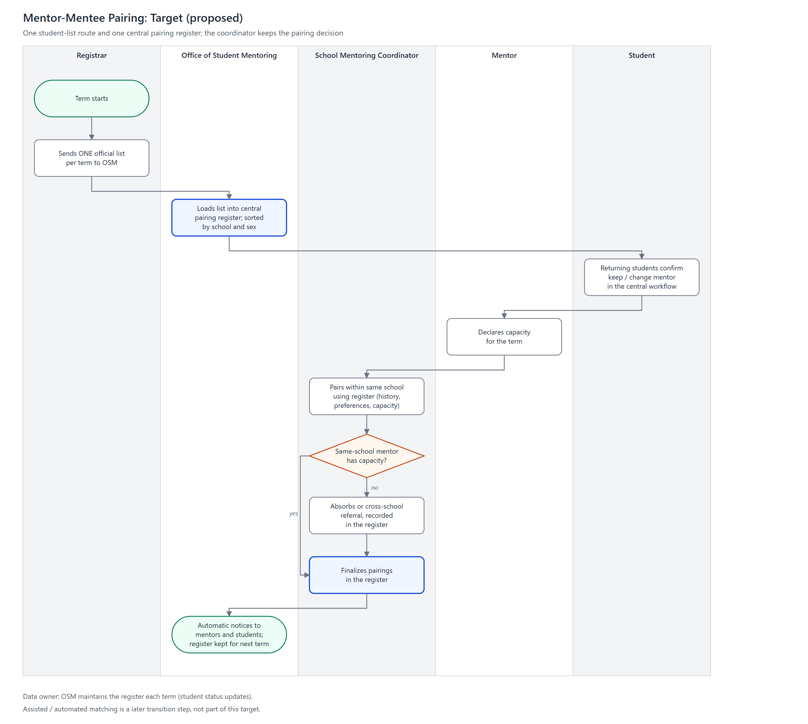
Figure 2. Mentor-Mentee Pairing (Target)
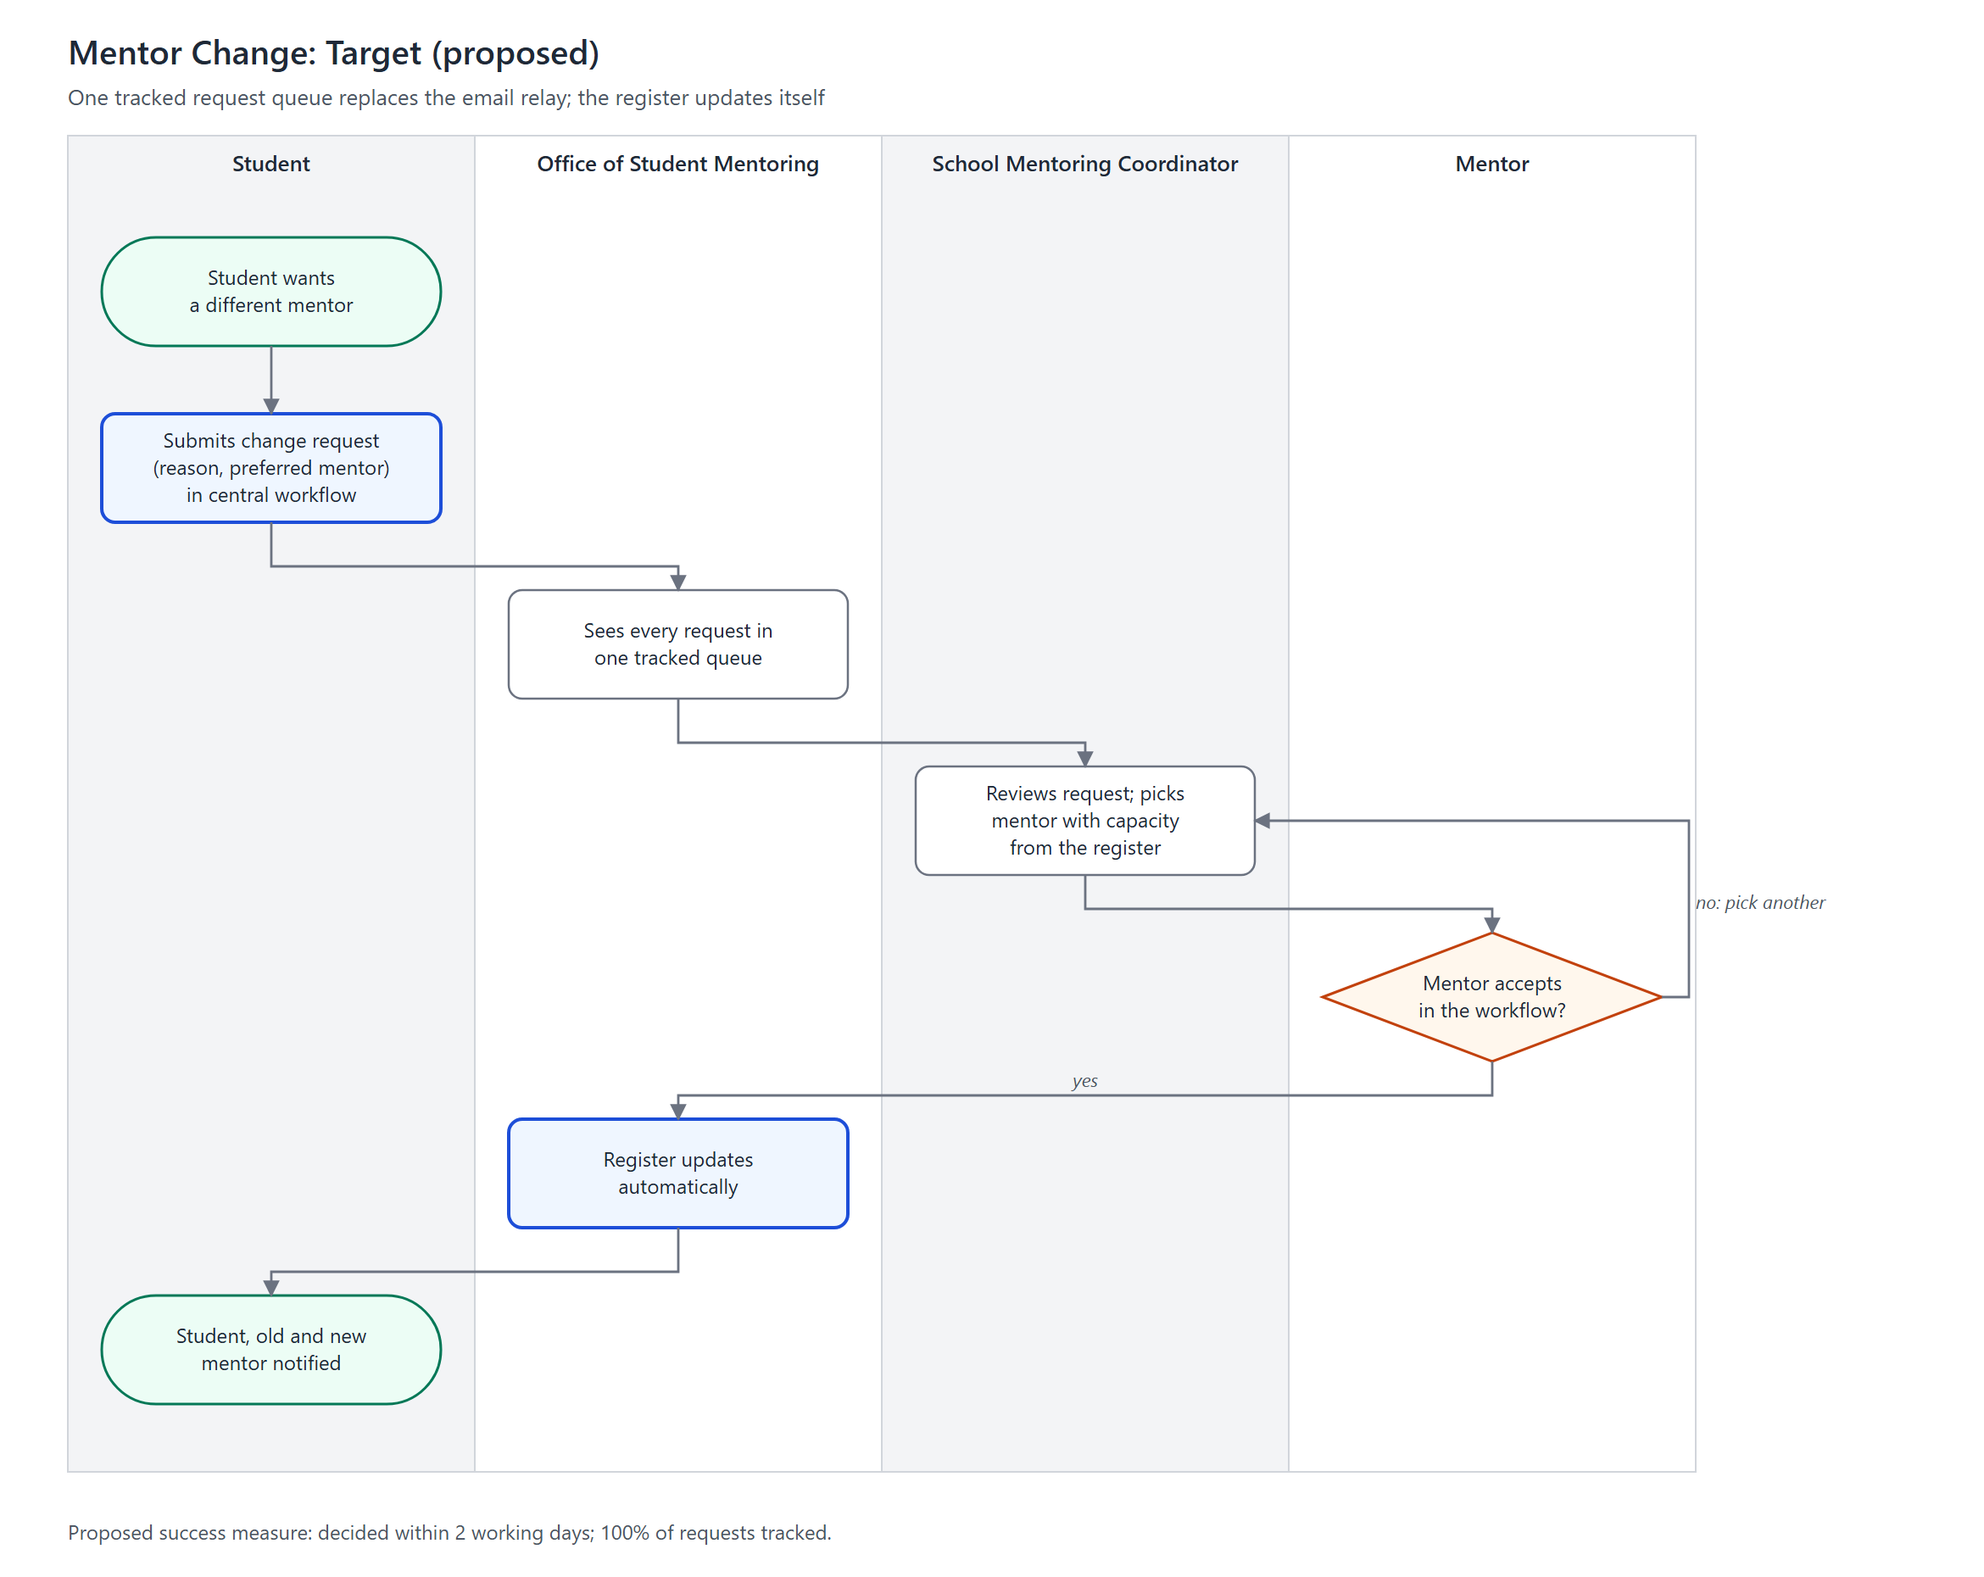
Figure 3. Mentor Change (Target)
Sources: Interview with OSM (2026-09-11); Interview with OSM (2026-09-28); Interview with SSE Mentoring Coordinator (2026-10-16); Interview with SED Mentoring Coordinator (2026-10-20).

Success Measures
Targets marked "proposed" are the architecture team's proposals and must be validated with OSM and the sponsor (CSA Executive Director).
ID | Success measure | Baseline (today) | Target | Traces to
SM-01 | Share of enrolled undergraduates with at least 3 confirmed mentoring sessions per semester | Confirmed sessions update OSM's master database, but pairings are split across the schools' own lists | 100% (unit's stated aim) | Driver 1, Driver 3
SM-02 | Share of enrolled students with an assigned mentor recorded in the central pairing register before sessions start | Pairings held in separate coordinator lists; final lists not kept | 100% (proposed) | Objective; Capability: Pairing
SM-03 | Previous term's final pairings retrievable at the start of the next term | Not retrievable; coordinators rebuild pairings by hand | 100% (proposed) | Capability: Pairing
SM-04 | Mentor-change requests captured and tracked in one queue | Requests arrive by email to OSM or coordinators; not tracked | 100% of requests (proposed) | Capability: Pairing Change Mgmt
SM-05 | Mentor-change turnaround (request to student notified) | About 2 days, by email relay | Within 2 working days, without email relay (proposed) | Capability: Pairing Change Mgmt
SM-06 | Session logs automatically matched to a registered mentee-mentor pairing | 0%: session logs are tied to a typed mentor email, not to a recorded pairing | 100% (proposed) | Capability: Session Logging & Compliance
SM-07 | Routes by which the official student list reaches coordinators | Two (via OSM, or coordinator asks the Registrar directly) | One: Registrar to OSM to coordinators (proposed) | Capability: Pairing
SM-08 | Semester compliance and evaluation report to the CSA Executive Director and ManCom | No formal reporting | One report per semester (proposed) | Driver 3; Capability: Evaluation & Reporting

Business Service Contracts
Business services exchanged between OSM and the parties at its boundary. Service levels are proposed and need agreement with each party.
ID | Business service | Provider → Consumer | What is provided | Proposed service level
BS-01 | Student List Provision | Registrar → OSM | Official list of enrolled students (name, official email, course, year level, school, sex) | Once per term, before pairing starts; updates for late enrollees
BS-02 | Approved Mentor Roster | OSM → School Mentoring Coordinators | ManCom-approved mentors per school, with each mentor's declared capacity for the term | Before pairing starts each term
BS-03 | Mentee-Mentor Pairing | School Mentoring Coordinators → OSM, mentors, students | Final pairings per school recorded in the central register; mentors and students notified | All students paired before sessions start (SM-02)
BS-04 | Mentor Change Handling | OSM and School Mentoring Coordinators → students, mentors | Request intake, decision, register update and notification | Within 2 working days (SM-05)
BS-05 | Session Log Confirmation | Mentors → OSM | Confirmation or correction request for each student-submitted session log, plus the required evaluation answer | Each log confirmed or returned for correction
BS-06 | Compliance and Evaluation Reporting | OSM → CSA Executive Director, ManCom | Per-student session compliance and program evaluation results | Once per semester (SM-08)
BS-07 | Mentor Approval | Supervisor → OpCom → OSM → ManCom | Recommended mentor candidates assessed against the (confidential) scorecard; ManCom approves the list | Before the term's roster is issued
BS-08 | Mentor Development | OSM with HR → mentors | Mentor Development Programs (MDP) within HR's development programs | Per OSM's yearly plan

Application Service Contracts
The application services below come from the Phases C and D document (Section 3.2). Service levels are proposed and need agreement with OSM and the IT Office.
ID | Application service | Consumer | What is provided | Proposed service level
S1 | Pairing Register | OSM, coordinators | Enrolled list import, mentor capacity, pairings, history across terms | Register loaded within one week of receiving the Registrar's list
S2 | Mentor Change Requests | Students, mentors, OSM, coordinators | One tracked queue; approved changes update the register | Within 2 working days (SM-05)
S3 | Session Logging | Students, mentors | Logs tied to the recorded pairing; mentor confirms by email link | Confirmation request sent to the mentor on submission
S4 | Compliance Monitoring and Reporting | OSM, CSA Executive Director | Session counts, early flags, semester report | Students below three sessions flagged at least 4 weeks before the semester ends; one report per semester (SM-08)
S5 | Notifications | All | Pairing notices, change results, reminders | Sent the same day as the triggering event

Implementation Guidelines
Business-level guidelines that any implementation must respect:
- The School Mentoring Coordinator keeps the pairing decision. The architecture supports pairing; it does not take it over.
- Pair students with mentors from the same school wherever possible. Cross-school referral and coordinator absorption remain allowed for overflow and must be recorded.
- Each school's student list is split between its male and female coordinators. Same-gender mentor pairing is not a university-wide rule; one coordinator (SSE) reported it as practice.
- Name one data owner at OSM who maintains the pairing register every term (graduates, transfers, new students).
- Replace email relays with tracked steps in one workflow; email may remain only as a notification channel.
- The schools' internal matching criteria stay outside the architecture (decision of 2026-09-14).

Implementation Specifications
Developed in Phase E (Opportunities and Solutions), which is outside the scope of this assignment (Phases A to D).

Implementation Standards
Business-level standards: the UA&P Student Handbook on Mentoring, and the three-sessions-per-semester policy (AY 2026-27). The mentor-approval scorecard is confidential and must stay restricted to OSM and the approving bodies.
Technology standards from Phase D (Section 4.2): the application runs within the university's Google Workspace where possible (TS1); UA&P sign-in for students, coordinators, and OSM, with email-link confirmation for external mentors (TS2); access by role and compliance with the Data Privacy Act of 2012 (TS3); browser access with nothing to install (TS4); one agreed Registrar list format (TS5); OSM owns the data and the IT Office maintains the tools (TS6).

Interoperability Requirements
Business-level interoperability needs (technical detail to follow in Phases C and D):
- The Registrar's student list must arrive in one agreed format that OSM can load without re-typing.
- The pairing register must be the one reference shared by OSM, all School Mentoring Coordinators and mentors.
- Every session log must reference a registered mentee-mentor pairing (today the schools' pairing lists are not connected to OSM's records).
- External mentors must be able to confirm sessions by email link without a university account.

IT Service Management Requirements
OSM owns the pairing register and refreshes it each term from the Registrar's list (graduates, transfers, new students). The IT Office maintains the application and its scripts (TS6).

Constraints
ID | Constraint | Source
C-01 | The three-sessions-per-semester requirement is non-negotiable. | Interview with OSM (2026-09-28)
C-02 | Pairings are decided by each school's Mentoring Coordinator, not by OSM. | Interviews with SSE and SED Mentoring Coordinators
C-03 | OSM has two staff (monitoring; mentor training). | Interview with OSM (2026-09-28)
C-04 | The Registrar's freshman list is only final after enrollment closes, which delays pairing. | Interviews with SSE and SED Mentoring Coordinators
C-05 | Strategic direction is set by the CSA operations committee and ManCom, not by OSM. | Interview with OSM (2026-09-28)
C-06 | The IT Office creates the forms and sheets; OSM manages them. | Interview with OSM (2026-09-28)
C-07 | Work follows the semester rhythm: pairing at the start, compliance checked by the end. | Interview with OSM (2026-09-11); Interview with SSE Mentoring Coordinator (2026-10-16)
C-08 | Mentor supply is limited; mentor loads range from 2 to 50 mentees, set by each mentor's willingness. | Interviews with SSE and SED Mentoring Coordinators

Assumptions
ID | Assumption | Status
A-01 | Students will log their sessions properly once logging is their responsibility. | Verified: required by the University's three-sessions-per-semester mentoring policy (AY 2026-27)
A-02 | The Registrar will agree to send one official list to OSM instead of to each coordinator. | To confirm with Registrar
A-03 | Coordinators will adopt one central workflow in place of their own lists and emails. | To confirm with coordinators
A-04 | Mentors will declare their capacity each term. | Confirmed (Interview with SSE Mentoring Coordinator (2026-10-16))
A-05 | The session-log sheet updates OSM's master database, but the schools' pairing lists are not connected to it. | Interview with OSM (2026-09-28); Aldrin (2026-10-29)
A-06 | The IT Office can support a single platform for these workflows. | To confirm with the IT Office

